BRITISH VALUES
Learning about British values includes democracy, the rule of law, mutual respect and tolerance and democracy.

Pupils involved in show and tell developing respect for others beliefs and values.  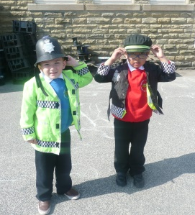 | Discrimination and stereotypes are challenged. | Through play pupils develop a sense of tolerance and acceptance for example same sex marriage.  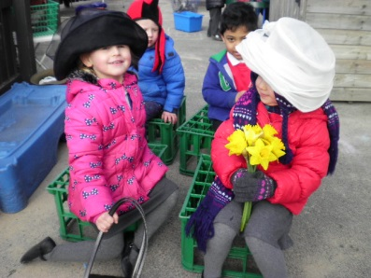
Different faiths are celebrated and explored.  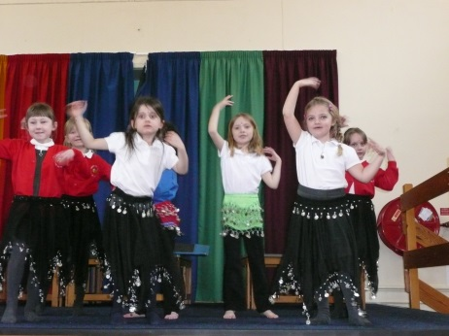 | Mutual Respect and Tolerance  People with different faiths and beliefs (or none) should be accepted ad tolerated and should not cause prejudice or discrimination | Through RE, stories are shared in different faiths and the similarities and differences discussed.  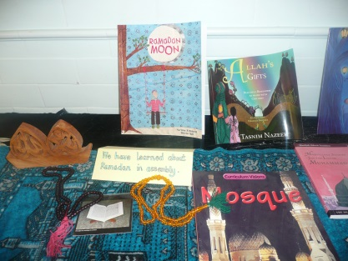
Assemblies share stories from different faiths and cultures to provide discussion. | 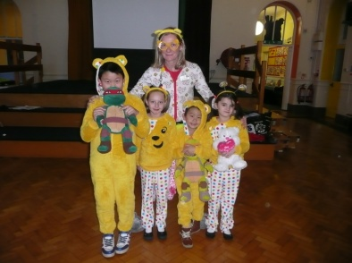  Pupils support charity events to benefit a range of people from different backgrounds, cultures and places in the world. | Positive attitudes are promoted for example disability, sexual orientation, beliefs, culture and faith.  