BRITISH VALUES
Learning about British values includes democracy, the rule of law, mutual respect and tolerance and democracy.

Pupils make their own choices with regards to learning. | Sanctuary weeks focusing on Christian values, giving children time to reflect on world issues. | Promoting the pupils’ different cultures through discussion, events and themed days.
Celebrating Chinese New Year. | Individual Liberty  An understanding that the freedom to choose and hold other faiths and beliefs is protected by law | PSHE and RE curriculum taught throughout school.
Tolerance of different family arrangements and awareness of sexual orientation.  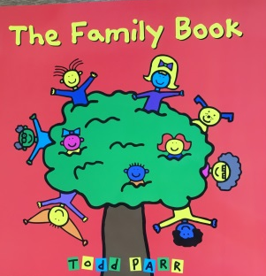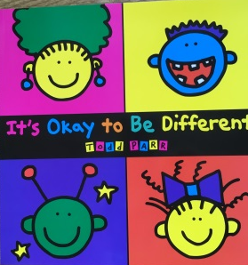 | The choice of school clubs to attend in and after school. | Assemblies to promote different beliefs and choices that can be made.

